**COMPSCI 345 / SOFTENG 350**

**Tutorial 6: Visual Design**

**Worth 1% of your final grade**

**Tutorial exercises should be undertaken in pairs, to discuss and share ideas**

**Each partner must create their own unique hi-fi prototype and write in their own words**

**You should plan to spend 50 minutes on this tutorial**

**Upload your completed worksheet to Canvas**

**Due by 6pm on Friday 15 May**

**Aims**

The aim of this tutorial is to give you experience in creating a high-fidelity prototype of a single screen.

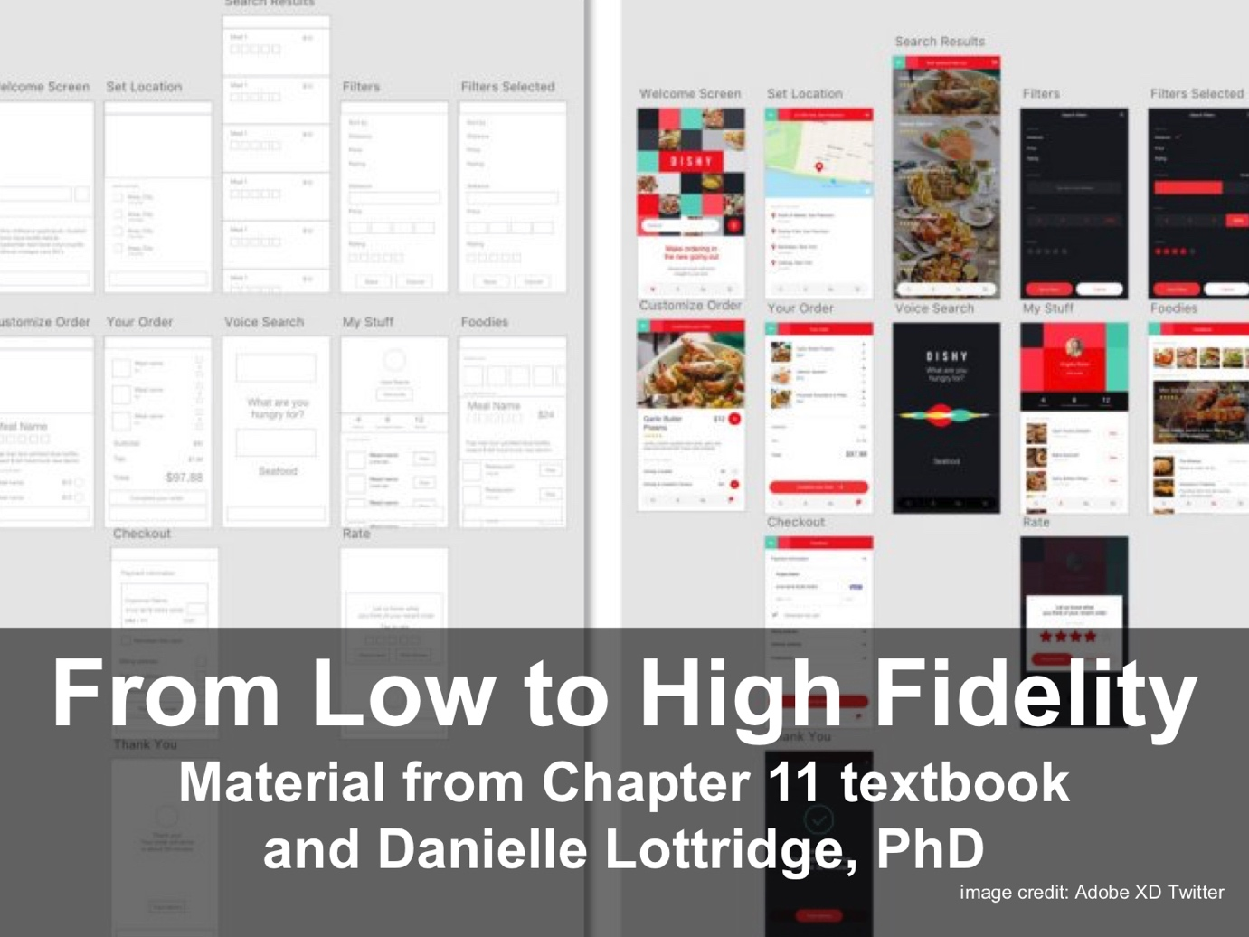

Figure 1. Comparison of low and high fidelity prototypes. Image courtesy of Adobe XD Twitter

**Background**

Your task is to prototype one smartphone screen in a takeout meal mobile phone app. Design one high-fidelity screen that enables a user to select a single side dish associated to a previous meal choice.

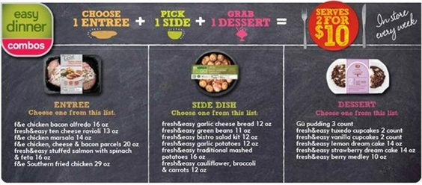

Figure 2. Menu for selection of side dishes for a meal. Source <https://www.pinterest.at/pin/480337116484718426/>

We will follow the prototyping approaches described in lectures 11 and 10, with the associated readings.

For this tutorial, you may use any digital tool that supports visual prototyping. We recommend Google slides or PowerPoint. You may include the image in Figure 2 (or portions of it) and any online images licensed for non-commercial reuse (see Fig. 3). You must cite all source URLs for online images included. Citations are not included in wordcount.

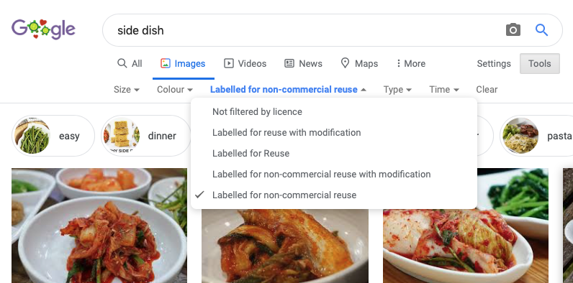

Figure 3. Example Google Image search for online images labelled for non-commercial reuse.

Submission: Convert your prototype to PDF. (No other file formats accepted.) Submit PDF to Canvas.

**Activity**

Consider this scenario: Imagine that the user has already selected the ‘ten cheese ravioli’ from the menu in Fig. 2. The user is at the stage of selecting a side dish.

In your pair, discuss:

1. how the app should display the relevant context of the choice made so far, where the user is in the overall process of ordering a meal, and the options for side dishes

Create one high-fidelity screen to show ‘a)’. Include typical elements of real apps, for example, an app logo and an icon for a shopping cart.

Describe the visual design of ‘a)’ in 250 words or less. This section should describe what visual principles were used when developing the design. Bullet points may be used for the writeup.

**Tutorial 6 Worksheet Rubric**

*Criteria*

* Prototype: Quality and visual design of ‘a)’
* Writeup: Coverage of visual design principles in description.
* Overall quality: Clarity of writing / prototype / descriptions and professionalism of the presentation.

*Assessment of criteria*

Criteria are assessed as excellent, good, satisfactory, unsatisfactory or fail.

*Submission notes*

Students: it is your responsibility to check the file that you submit. Is it the right file? (Not a blank one, not one from another course). Are images visible?

If there are problems with the file due to students not checking their submission, the late penalty will be applied for resubmission.

<https://commons.wikimedia.org/wiki/File:Flickr_-_cyclonebill_-_Ravioli_med_skinke_og_asparges_i_mascarponecreme.jpg>

<https://flickr.com/photos/160866001@N07/33729007398/>

<https://www.flickr.com/photos/gpeters/3010150846>

a)

b)

